[](https://www.google.dk/url?sa=i&rct=j&q=&esrc=s&source=images&cd=&cad=rja&uact=8&ved=0ahUKEwjQ_6TKg4zXAhVBEpoKHbg4AiUQjRwIBw&url=https://www.mycutegraphics.com/graphics/book-images.html&psig=AOvVaw2yLOurGg5WYKquA7uMKzwv&ust=1509029564104581)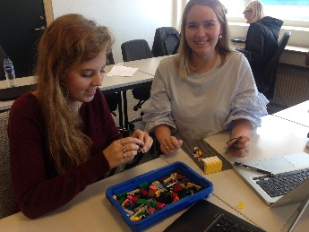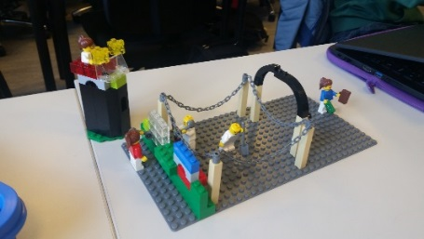[](http://www.google.dk/url?sa=i&rct=j&q=&esrc=s&source=images&cd=&cad=rja&uact=8&ved=0ahUKEwj_6caAg4zXAhVjCZoKHdsjAKcQjRwIBw&url=http://www.playbuzz.com/maycon10/quem-voc-seria-na-novela-c-mplices-de-um-resgate&psig=AOvVaw2KvXF2JU6fRcqetqr9xRV8&ust=1509029472010886)[](http://www.google.dk/url?sa=i&rct=j&q=&esrc=s&source=images&cd=&cad=rja&uact=8&ved=0ahUKEwimoMHwg4zXAhVGIJoKHTHaB-AQjRwIBw&url=http://www.publicdomainpictures.net/view-image.php?image%3D155227%26picture%3Dlight-bulb&psig=AOvVaw0etW74VAtoQFwO269c2izv&ust=1509029704141464)[](http://www.google.dk/url?sa=i&rct=j&q=&esrc=s&source=images&cd=&cad=rja&uact=8&ved=0ahUKEwilw7WowIzXAhUmQpoKHbakALoQjRwIBw&url=http://hbcteens.com/no-money/&psig=AOvVaw2BSa5TvwFuFsQ9f8vOqm_1&ust=1509045865384989)[](http://www.google.dk/url?sa=i&rct=j&q=&esrc=s&source=images&cd=&cad=rja&uact=8&ved=0ahUKEwjHqqr0wIzXAhUKAZoKHW31CIgQjRwIBw&url=http://cliparting.com/free-thumbs-up-clipart-9655/&psig=AOvVaw2ixfpkRlJTD94ByCFn2vPK&ust=1509046091308673)[](https://www.google.dk/url?sa=i&rct=j&q=&esrc=s&source=images&cd=&cad=rja&uact=8&ved=0ahUKEwi60_fJwIzXAhWqKJoKHeqKCngQjRwIBw&url=https://www.pinterest.com/pin/273945589807302115/&psig=AOvVaw1kJ7nG-iasTOhUxsXNM9tM&ust=1509045986407364)[](http://www.google.dk/url?sa=i&rct=j&q=&esrc=s&source=images&cd=&cad=rja&uact=8&ved=0ahUKEwjXkuiKhIzXAhVLOJoKHWINBMUQjRwIBw&url=http://livesmartly.co/4-tips-help-build-confidence/&psig=AOvVaw1Zl5Af34XbLdzyHPACmufJ&ust=1509029762719425)[](http://www.google.dk/url?sa=i&rct=j&q=&esrc=s&source=images&cd=&cad=rja&uact=8&ved=0ahUKEwjY9_eQ7ovXAhUjQJoKHVFvC0sQjRwIBw&url=http://www.pngmart.com/image/19852&psig=AOvVaw3-e26dMFclJe1_oIfX1_Bn&ust=1509023864455244)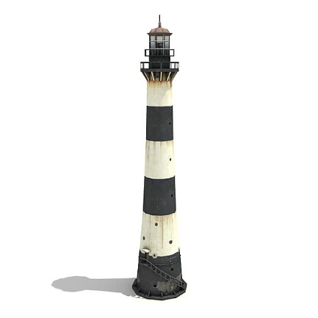

FAGSTOF

Er eleverne klar til at arbejde innovativt? Hvordan skal vi implementere innovation på skolen?